Motion and Force in a Gravitational Field

Revision Problems 3: Circular Motion Due: _____________________

Name: __________________________________________ (20 marks)
- The mass of a cyclist and bike is 90.0 kg. The cyclist rides around a circular bike track of radius 1.00 x 10² m and completes 15.0 revolutions of the track in 10.0 minutes. Calculate her centripetal force. (3 marks)

m = 90 kg 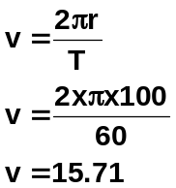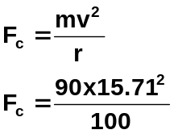
r = 100 m
15 rev = 600 s
1 rev = T
T = 600 / 15
T = 40 s F_{c} = 222 N
[1 mark] [1 mark] [1 mark]

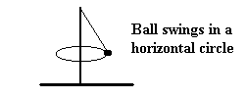

- A beach game involves hitting a ball tied to a pole with a piece of string with the ball moving in a horizontal circle. In one game the 0.400 kg ball swings around and around at an angle to the vertical. The ball takes 1.80 s for one revolution. What is the tension in the string if the radius of swing is 0.950 m?
(3 marks)

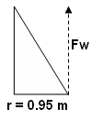
F_{W} = mg = 0.4 x 9.8 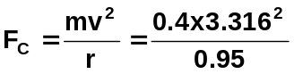
= 3.92 N F_{c} = 4.63 N [1 mark]
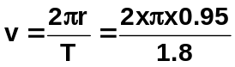

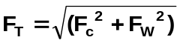
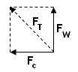
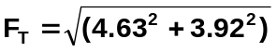 v = 3.316 ms⁻¹
[1 mark]

F_{T} = 6.07 N
[1 mark]

- A child jumps on the end of a farm gate and swings it closed. If the gate was at 90⁰ to its closed position, using reasonable estimates for mass, radius and period, determine the child’s centripetal acceleration as she closed the gate. (3 marks)

m = 30 kg  r = 1.5 m  T = 3 s | 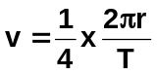  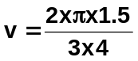  v = 0.785 ms⁻¹  [1 mark] | 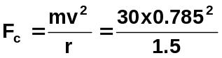  F_{c} = 12.3  As an estimate,  F_{c} = 12 N [1 mark]  (range between 1N and 300 N)  Maximum 2 s.f. [1 mark]

- A roller-coaster has a vertical loop of radius 40.0 m. The owners of the roller-coaster advertise that the passengers will feel weightless while riding the loop.

- What minimum speed would the roller-coaster need to be doing at the top of the loop for this to be true?  (2 marks)  F_{c} = F_{w}  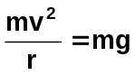 [1 mark]  Cancel mass  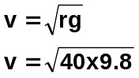  v = 19.8 ms⁻¹ [1 mark] | - Using your understanding of conservation of energy, what then would be the speed of the roller-coaster at the bottom of the loop? (3 marks)  E_{p} lost = E_{k} gained [1 mark]  At top, both E_{p} and E_{k} as moving so  ( ½ mv² _{top} ) + mgh = ½ mv² _{bottom} [1 mark]  Masses cancel throughout  (0.5 x 19.8²) + (9.8 x 80) = 0.5v²  196.02 + 784 = 0.5v²  980.2 x 2 = v²  v = 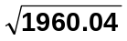  v = 44.3 ms⁻¹ [1 mark]

- A 75.0 kg student has an apparent mass of 63.0 kg at the highest point on a steadily rotating Ferris wheel. What is the apparent mass of the student at the lowest point? (4 marks)

Normal weight = 75 x 9.8 = 735 N  Apparent weight = 63 x 9.8 = 617.4 N  [1 mark]  Difference is due to F_{c} which reduces normal weight  F_{c} = 735 – 617.4  = 117.6 N  [1 mark] | At bottom:  F_{T} = F_{c} + F_{w}  = 117.6 + 735  = 852.6 N [1 mark]  Apparent weight = mg  852.6 = m x 9.8  m = 87 kg  therefore student appears to have a  mass of 87.0 kg [1 mark]

- A railway line goes around a curve of radius 5.00 x 10³ m. It is designed to carry a train travelling at 1.00 x 10² ms⁻¹. What would be the angle of banking for the tracks which would result in the best cornering. (2 marks)
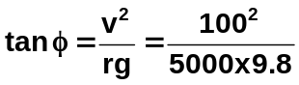
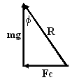
tan φ = Fc = mv²/r [1 mark]
mg mg
tan φ = v²
rg tan φ = 0.2041
φ = 11.5⁰ [1 mark]

